Preliminary Project Proposal
Student ID: MC648113 | MC642703
Name: Zhai XiaoNan | Zhang ZiYang
Course Code: CISC7204-001-C
Course Name: Data Science and Data Visualization
coursework item: CISC7204 Assignment 02

1. Project Topic Name
Employment, Consumer Spending, and Regional Economic Stress: A State-Level Panel Study of Unemployment and Personal Consumption Expenditures in the U.S. (2000–2025)

2. Research Question
Between 2000 and 2025, after controlling for state and year fixed effects, does a rise in annual-average unemployment across U.S. states correspond to a statistically significant drop in state-level real per-capita personal consumption expenditures (PCE), or its annual growth rate? As a secondary contextual analysis, what co-movement patterns exist among the national credit-card delinquency rate, national unemployment rate, and aggregate consumption over the same time period?
Expected Relationships:
Higher state-level unemployment is expected to bring about a reduction in a state’s real per-capita PCE level or a decline in the annual PCE growth rate, indicating a negative correlation between the two variables.
A rise in lagged one-period state-level unemployment is expected to lower household consumption spending in the subsequent year, suggesting a lagged negative effect.
Descriptive analysis only for the national level: higher national unemployment is expected to correspond to an elevated credit-card delinquency rate. This component will be examined purely descriptively and will not be incorporated into the state-level panel regression model.
Region and Domain Category:
• Region: U.S. State-level, including 50 states and the District of Columbia.
• Domain Category: Macroeconomics, Regional Economics, Consumer Finance, and Consumer Spending Analysis.

3. Project Purpose
Outcomes: This project will complete an end-to-end data-science workflow (formulating research questions, acquiring official public data, cleaning and merging datasets, EDA, panel regression, spatial visualization, reproducible reporting). It directly aligns with the course learning outcomes and my study plans in macroeconomics, consumer finance, regional economics, policy evaluation, and data analysis.
Skills:
• Data analysis using Python 3, including pandas, numpy, matplotlib, seaborn, plotly and statsmodels.
• Data cleaning, state FIPS code standardization, annual aggregation of monthly unemployment data, time series alignment, and missing value handling.
• Statistical analysis: correlation, scatter plots with linear fitting and confidence intervals, lag analysis, panel regression, state and year fixed effects, and robust standard errors.
• Spatial visualization: U.S. state-level choropleth maps for unemployment rates and consumer spending growth.
Knowledge: Gain familiarity with state-level unemployment and labor-market pressure, state-level PCE as a measure of consumer spending, panel-data structures and regression techniques, the distinction between correlation and causation, and analytical risks including lag effects and omitted-variable bias.

4. Dataset Information
Multiple datasets are used for this project; all primary and alternative sources are documented in a source log.
• BLS Local Area Unemployment Statistics – State Unemployment: https://www.bls.gov/lau/ (official state-level monthly rates, aggregated to a state-year panel).
• BEA – State Personal Consumption Expenditures: https://www.bea.gov/data/consumer-spending/state (annual state-level PCE).
• FRED – State Unemployment Rate Release Table: https://fred.stlouisfed.org/release?rid=112 (CSV/API download).
• FRED – Delinquency Rate on Credit Card Loans (DRCCLACBS): https://fred.stlouisfed.org/series/DRCCLACBS (national quarterly; contextual background only).
• FRED – National Unemployment Rate (optional contextual): https://fred.stlouisfed.org/series/UNRATE
Data availability note:
No reliable public state-level credit card delinquency series was identified for the period, so the project runs no state-level delinquency panel; the national rate is used only as descriptive context. This limitation is documented in the source log.

5. Project Tasks and Deliverables
Task 1: Data Confirmation and Acquisition: confirm study period, scope, variables, and sources; verify and document that state-level delinquency data are unavailable; download raw state unemployment, state PCE, and national delinquency data. Deliverable: raw datasets and a source log.
Task 2: Data Cleaning and Panel Construction: standardize state names and FIPS codes, aggregate monthly unemployment values to annual averages, align with annual PCE data, handle missing values, and merge into a state-year panel; compute real per capita PCE and annual PCE growth where data permit. Deliverable: cleaned merged state-year panel dataset stored within the notebook.
Task 3: Exploratory Data Analysis: generate time trend plots, correlation matrices, state-level choropleth maps, scatter plots with linear fitting and confidence intervals, and lag comparison charts. Deliverable: EDA charts and exploratory observations documented inside the notebook.
Task 4: Statistical and Regression Analysis: examine correlations between state unemployment and consumer spending; produce scatter/fitting plots with confidence bands; test lagged relationships; run baseline pooled OLS and state/year fixed-effects panel regressions with robust standard errors; conduct descriptive comparison of national delinquency data. Deliverable: correlation outputs, fitted plots and simplified regression tables within the notebo-ok.
Task 5: Final Visualization and Report: prepare final choropleth maps, scatter plots, lag and panel analysis charts, and write explanatory interpretations. Deliverable: fully runnable, reproducible Jupyter Notebook integrating all analysis, plots and explanations.

6. Criteria for Success
Success is defined by the completeness, reproducibility, and ability to answer the research question of the deliverables in Tasks 1–5 (confirmed data and source log; cleaned panel dataset stored in notebook; EDA charts; correlation, scatter/fitting, lag, and regression results; final maps, charts, and runnable notebook). A self-evaluation checklist includes: data missing rate < 5%, fully reproducible Python code, all 50 U.S. states and DC visualized on maps, scatter plots with confidence intervals, completed panel regression with state/year fixed effects and robust standard errors, interpretation of regression estimates regardless of significance, and a source log documenting the delinquency-data limitation.

7. Visualization Justification
The visualizations combine statistical trends and spatial distributions to address the core research question. The scatter plot with a linear trendline and confidence interval tests the hypothesized negative correlation. Preliminary Python-based exploratory results show that a one-percentage-point rise in median state unemployment is associated with an approximately 1.0-percentage-point drop in aggregate national PCE growth (OLS：β ≈ -0.996, p = 0.007；HC3 robust standard error：p = 0.009), consistent with the expected negative relationship (Figure 1). Note that the current preliminary results are at the national aggregate level; the state-year fixed-effects panel regression will be completed in Task 4.Figure 2 presents side-by-side choropleth maps of state unemployment for 2010 Q1 and 2024 Q1, while Figure 3 shows 2010-2024 cumulative state PCE growth; together they explore whether high-stress labor markets display geographic clustering (Figures 2–3). A state-year panel heatmap and within-state correlation chart illustrate heterogeneity in this association across time and individual U.S. states (Figures 4–5).
The final national time-series plot provides contextual descriptive evidence linking credit-card delinquency, national unemployment, and aggregate consumption (Figure 6). This national-level descriptive exercise is distinct from the state-level panel regression analysis. Preliminary descriptive results show positive annual co-movement (Pearson r ≈ 0.346,national unemployment vs. national delinquency, annual). Importantly, these are purely exploratory visual outputs. The project will formally test these patterns using fixed-effect panel regression with robust standard errors. All figures are built from publicly available official datasets and are fully reproducible in the accompanying Jupyter Notebook.
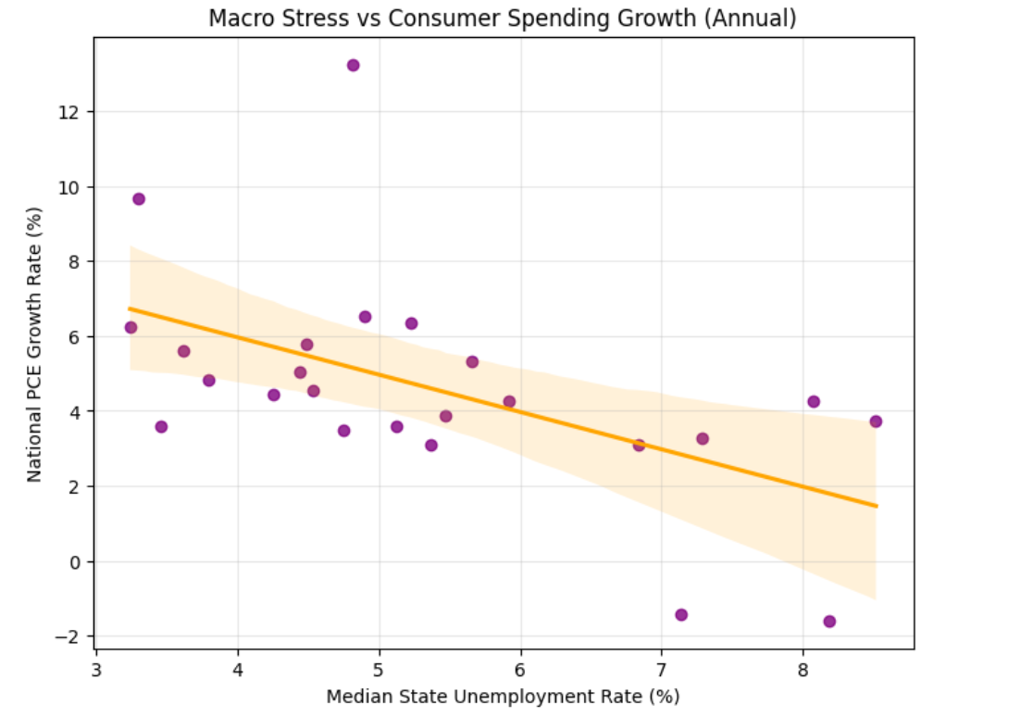
Figure 1: Scatter plot of annual median state unemployment vs. national PCE growth, OLS fit and 95% confidence band
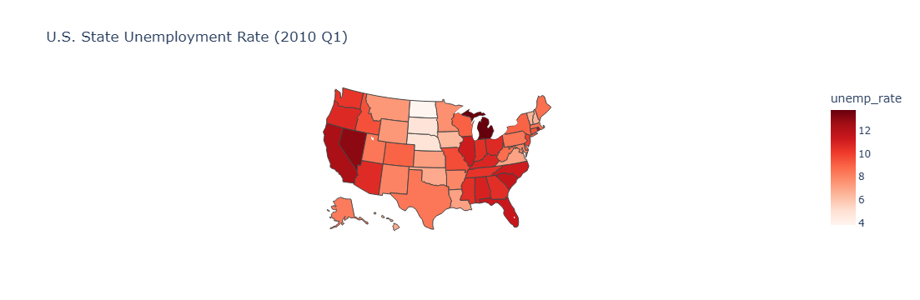 | 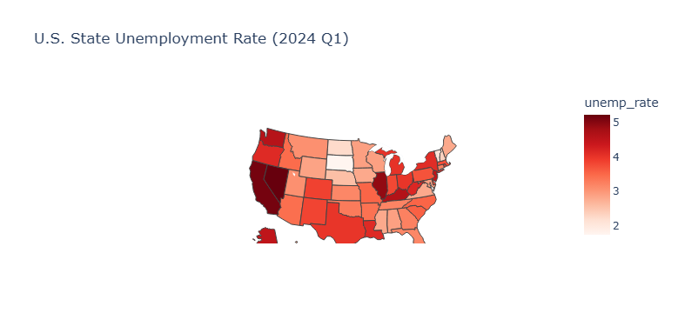

Figure 2: Choropleth maps of U.S. state unemployment rate, 2010 Q1 and 2024 Q1
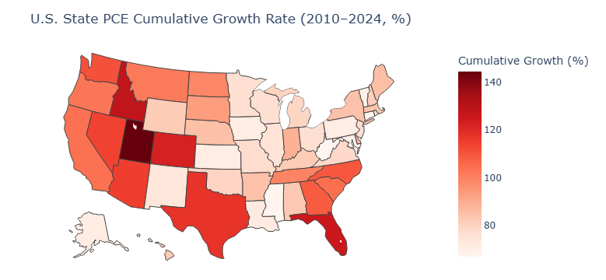
Figure 3: Choropleth map of state PCE cumulative growth, 2010–2024
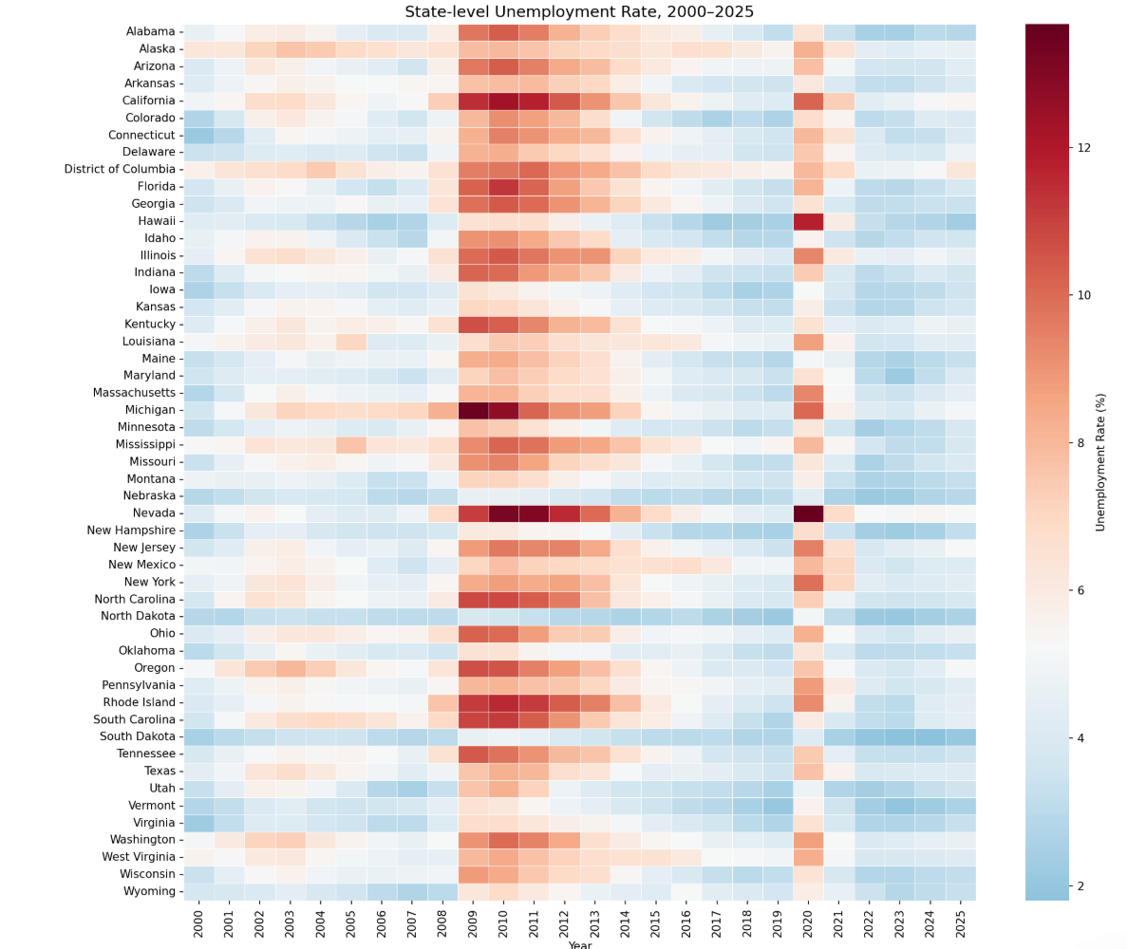
Figure 4: State-level PCE index heatmap (2000 = 100), 2000–2025
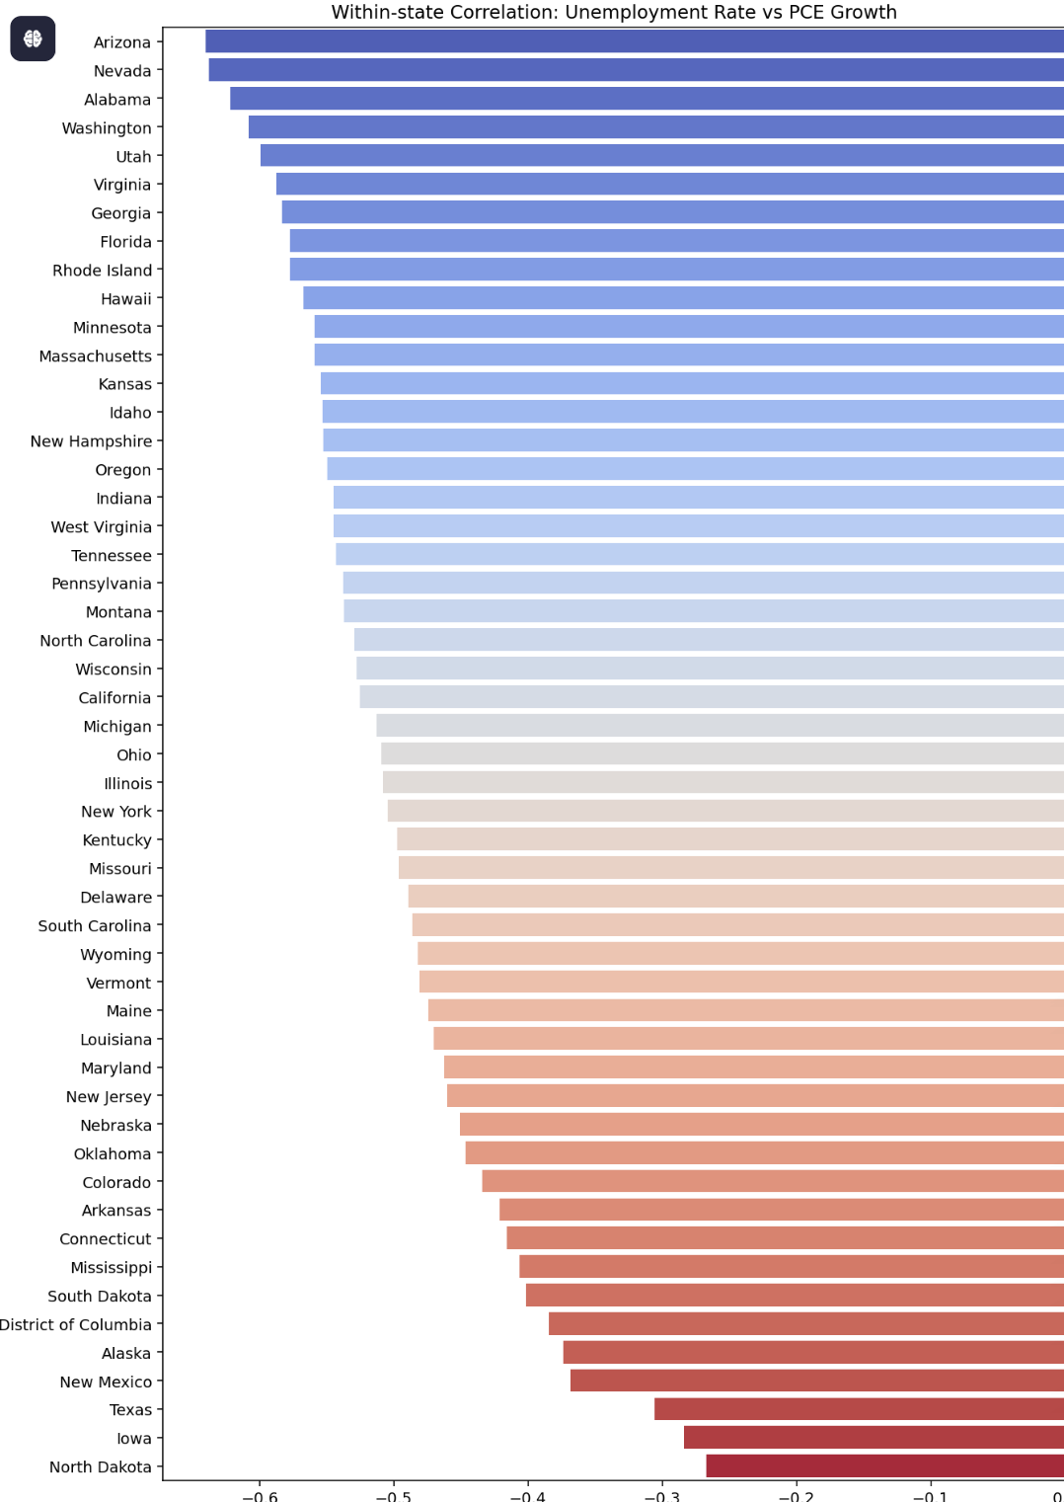
Figure 5: Within-state correlation: unemployment vs. PCE growth by state
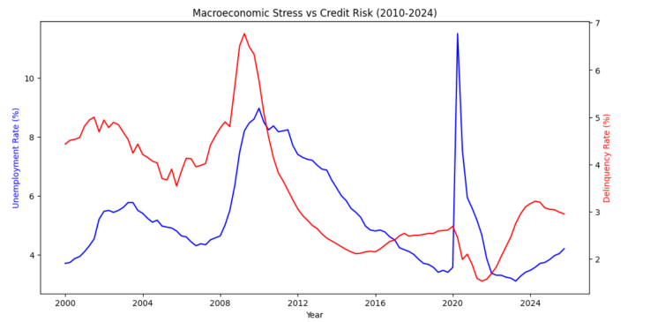
Figure 6: National credit-card delinquency rate vs. median state unemployment rate, dual-axis co-movement

8. Project Collaboration
This is a two-person team project. The work allocation is defined as follows:
Zhai XiaoNan : Draft and revise the project proposal, incorporate empirical results from code.
Zhang ZiYang: Perform data processing, write Jupyter Notebook code and generate all charts.
Both members reviewed the proposal and agreed on the research design.
Declaration of AI Usage - MC648113 + Zhai XiaoNan  Did I use an AI LLM? Yes  Exact LLM used: Doubao  Web Browser used: Google Chrome at doubao.com | Declaration of AI Usage - MC642703 + Zhang ZiYang  Did I use an AI LLM? Yes  Exact LLM used: DeepSeek  Web Browser used: Google Chrome at deepseek.com

